Check on Cloud Nine to find your next clue.

hint: water fountains



Go upstairs and check the pockets.

hint: pool

\*please be sure to leave this clue here for the next person!

Look for something living in the conference room.

hint: green

\*please be sure to leave this clue here for the next person!

Vulcan has his eye on the next clue, but you may have to climb some stairs. Look for a machine that dispenses candy.

hint: cube

\*please be sure to leave this clue here for the next person!

To find your final clue, sound out these images.

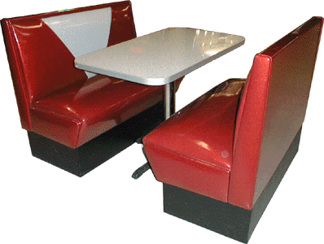

\*please be sure to leave this clue here for the next person!